Day in the Life of the Hudson River 10/13/22
East River Park Promenade, E 7th St, NY
East RIVER MILE: 3
Salt Front: ~ 76
LES Ecology Center– Jennifer Bombardier
NEST+4 5th grade students
52 students & 2 adults
Latitude °N & Longitude -- °W
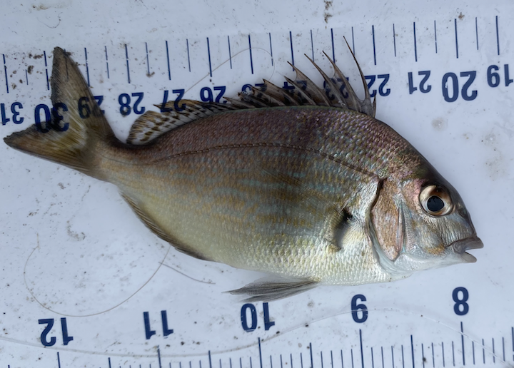
Small Scup (Porgy) ~12 cm
Location: East River Park, New York, NY
Area: On the East River Promenade near the northern corner of the track
Sampling Site: Grassy, altered banks, and a pipe entering the water
Surrounding Land Uses: 50% Urban/Residential, 50% Park
Shoreline: NR
River Bottom: NR
Water: Choppy
Plants in the Water: NR
*NR = Not read/recorded
ITEM |  | Time |  | Reading |  |  |  | Comments
Physical
Air Temperature- NR
Wind Speed: NR |  |  |  | Anemometer |  |  | Beaufort | Direction
Weather today |  | 10:30 AM |  | >75% cloud cover |  |  | No Rain
Weather the past 3 days: |  | Clear and cool and dry
Tides- NR |  | Time |  | Rising, Falling, Unchanged |  |  | Water Height (cm)
Current- NR |  | Time |  | Cm/sec |  | Knots | North/South | Ebb/Flood/Still
Water Temperature- |  | 10:20 AM  1:15 PM |  | 17°C  17°C |  |  | 64°F  63°F
Turbidity- Long Sight Tube (cm) |  | 10:20 AM |  | Recorded twice as 120 cm which means beyond the range of the tube as the long tube is 120cm in length
Chemical
Salinity-Hydrometer |  | 10:20 AM  1:20 PM |  | 24, 24 and 23 ppt  24 ppt X 3 readings
Standardized Salinity – Refractometer |  | 10:30 AM |  | 25 ppt
DO – NR |  | Time |  | Temp |  |  | ppm DO | % saturation
pH – Meter |  | 10:20 AM |  | 7.6
Nitrates- NR
Phosphates- NR
Alkalinity- NR
Biological-
Fish – Rod and Reel |  | Number |  | Name |  |  | Length of longest | Length of smallest
12:15 PM |  | 1 |  | Scup (porgy)  /stenotomus chrysops |  |  | 12 cm
Fish Totals |  | TOTAL: 1 |  | Diversity: 1
Macroinvertebrates |  | Number |  | Name |  |  | Length of longest | Length of smallest
Macroinvertebrate Totals |  | TOTAL: 0 |  | Diversity:0
Sediment Core – NR
Length | H2S smell |  | Oxid Top |  | Oil |  | Grain Size | Other Features
Boats- NR
 | Time |  | Name |  | Color |  | North/Southbound | Light/Loaded
Commercial
Recreational

